***C PROGRAM LAB TASK-3 SOLUTIONS***

**1. Write a program in C to store elements in an array and print it.**

#include <stdio.h>

int main()

{

int arr[10];

int i;

printf("\n\nRead and Print elements of an array:\n");

printf("-----------------------------------------\n");

printf("Input 10 elements in the array :\n");

for(i=0; i<10; i++)

{

printf("element - %d : ",i);

scanf("%d", &arr[i]);

}

printf("\nElements in array are: ");

for(i=0; i<10; i++)

{

printf("%d ", arr[i]);

}

printf("\n");

return 0;

}

Output:

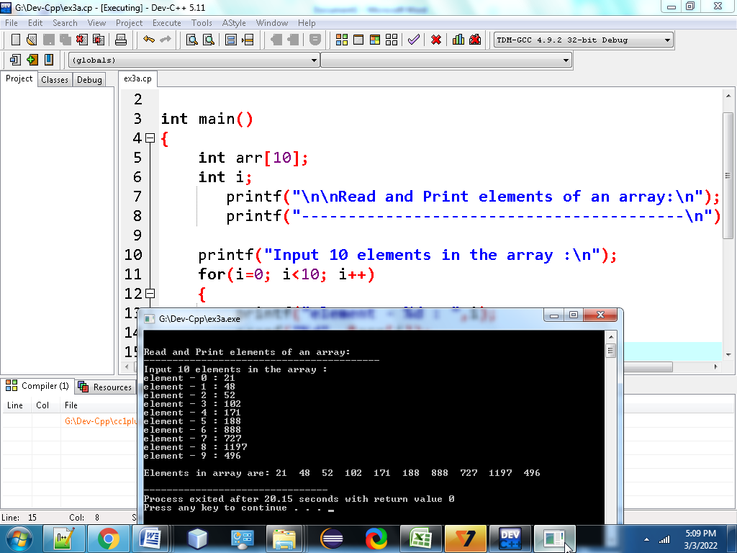

2.Write a program in C to read n number of values in an array and display it in reverse order. ?

#include <stdio.h>

int main()

{

int i,n,a[100];

printf("\n\nRead n number of values in an array and display it in reverse order:\n");

printf("------------------------------------------------------------------------\n");

printf("Input the number of elements to store in the array :");

scanf("%d",&n);

printf("Input %d number of elements in the array :\n",n);

for(i=0;i<n;i++)

{

printf("element - %d : ",i);

scanf("%d",&a[i]);

}

printf("\nThe values store into the array are : \n");

for(i=0;i<n;i++)

{

printf("%d ",a[i]);

}

printf("\n\nThe values store into the array in reverse are :\n");

for(i=n-1;i>=0;i--)

{

printf("%d ",a[i]);

}

printf("\n\n");

return 0;

}

Output:

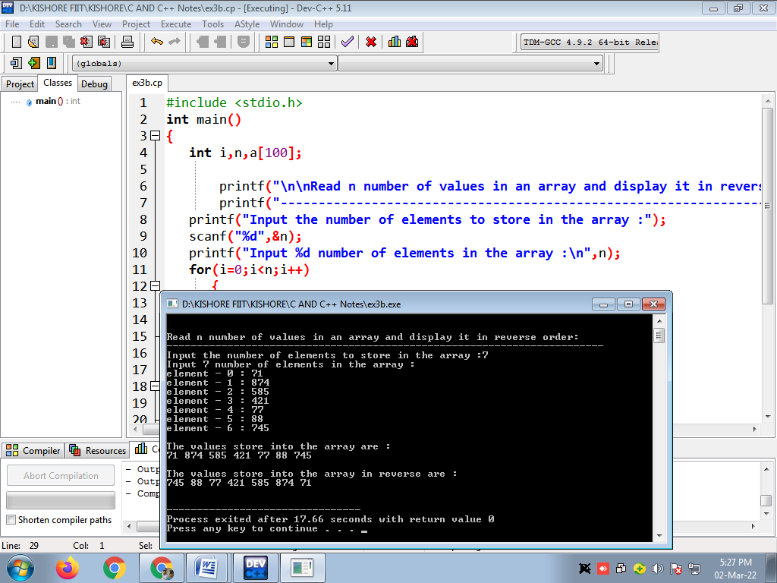

**3. Write a program in C to find the sum of all elements of the array.**

#include <stdio.h>

int main()

{

int a[100];

int i, n, sum=0;

printf("\n\nFind sum of all elements of array:\n");

printf("--------------------------------------\n");

printf("Input the number of elements to be stored in the array :");

scanf("%d",&n);

printf("Input %d elements in the array :\n",n);

for(i=0;i<n;i++)

{

printf("element - %d : ",i);

scanf("%d",&a[i]);

}

for(i=0; i<n; i++)

{

sum += a[i];

}

printf("Sum of all elements stored in the array is : %d\n\n", sum);

return 0;

}

***Output:***

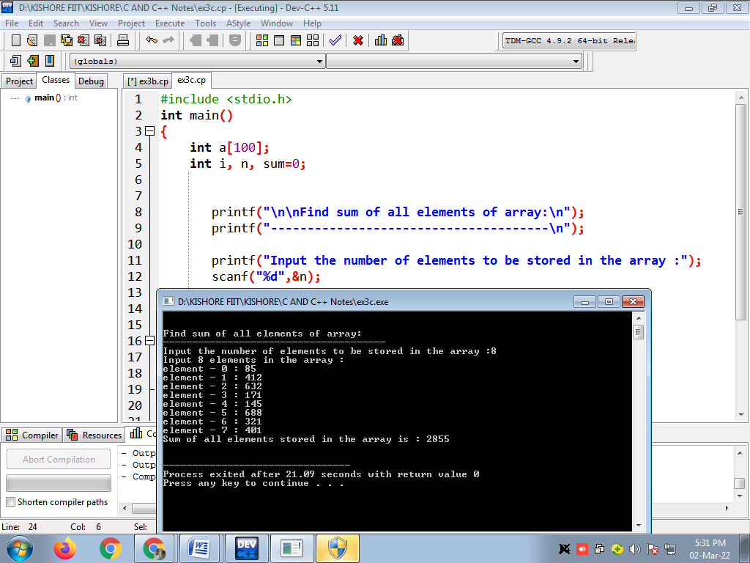

**4.** Write a program in C to copy the elements of one array into another array.

#include <stdio.h>

int main()

{

int arr1[100], arr2[100];

int i, n;

printf("\n\nCopy the elements one array into another array :\n");

printf("----------------------------------------------------\n");

printf("Input the number of elements to be stored in the array :");

scanf("%d",&n);

printf("Input %d elements in the array :\n",n);

for(i=0;i<n;i++)

{

printf("element - %d : ",i);

scanf("%d",&arr1[i]);

}

for(i=0; i<n; i++)

{

arr2[i] = arr1[i];

}

printf("\nThe elements stored in the first array are :\n");

for(i=0; i<n; i++)

{

printf("% 5d", arr1[i]);

}

printf("\n\nThe elements copied into the second array are :\n");

for(i=0; i<n; i++)

{

printf("% 5d", arr2[i]);

}

printf("\n\n");

return 0;

}

Output:

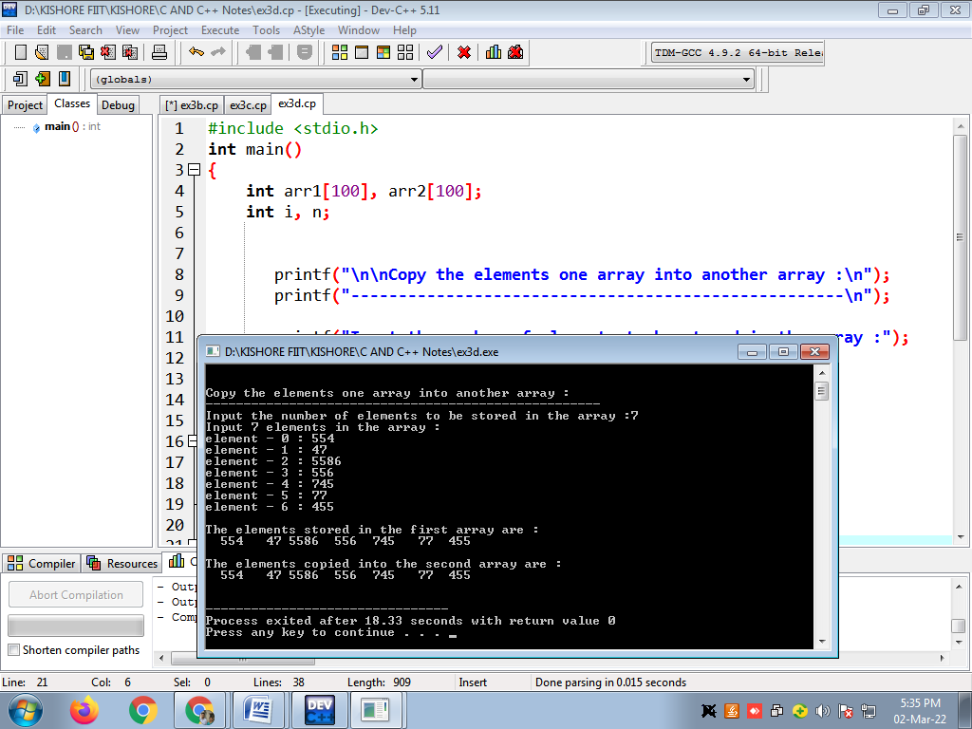

**5. Write a program in C to count a total number of duplicate elements in an array.**

#include <stdio.h>

int main()

{

int arr1[100];

int arr2[100];

int arr3[100];

int n,mm=1,ctr=0;

int i, j;

printf("\n\nCount total number of duplicate elements in an array:\n");

printf("---------------------------------------------------------\n");

printf("Input the number of elements to be stored in the array :");

scanf("%d",&n);

printf("Input %d elements in the array :\n",n);

for(i=0;i<n;i++)

{

printf("element - %d : ",i);

scanf("%d",&arr1[i]);

}

{

arr2[i]=arr1[i];

arr3[i]=0;

}

for(i=0;i<n; i++)

{

for(j=0;j<n;j++)

{

if(arr1[i]==arr2[j])

{

arr3[j]=mm;

mm++;

}

}

mm=1;

}

for(i=0; i<n; i++)

{

if(arr3[i]==2){ctr++;}

}

printf("The total number of duplicate elements found in the array is: %d \n", ctr);

printf("\n\n");

return 0;

**}**

Output:

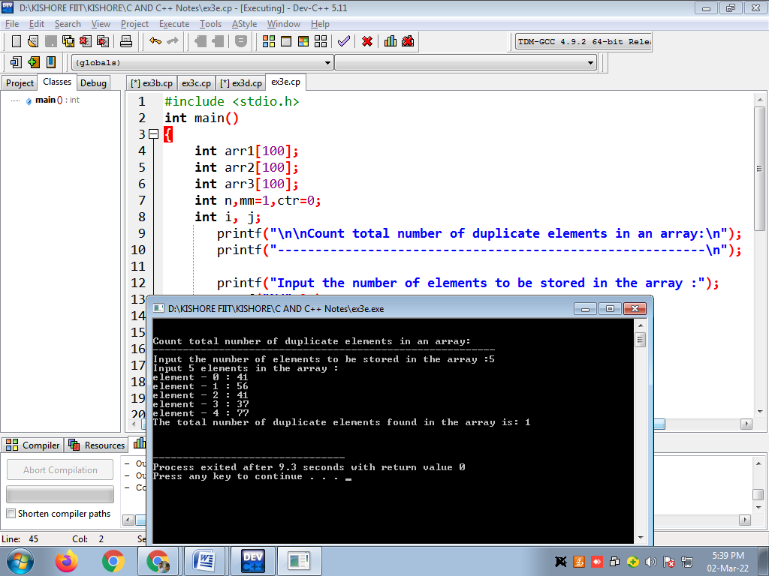

**6. Write a program in C to print all unique elements in an array.**

**#include <stdio.h>**

**int main()**

**{**

**int arr1[100], n,ctr=0;**

**int i, j, k;**

**printf("\n\nPrint all unique elements of an array:\n");**

**printf("------------------------------------------\n");**

**printf("Input the number of elements to be stored in the array: ");**

**scanf("%d",&n);**

**printf("Input %d elements in the array :\n",n);**

**for(i=0;i<n;i++)**

**{**

**printf("element - %d : ",i);**

**scanf("%d",&arr1[i]);**

**}**

**printf("\nThe unique elements found in the array are: \n");**

**for(i=0; i<n; i++)**

**{**

**ctr=0;**

**for(j=0,k=n; j<k+1; j++)**

**{**

**if (i!=j)**

**{**

**if(arr1[i]==arr1[j])**

**{**

**ctr++;**

**}**

**}**

**}**

**if(ctr==0)**

**{**

**printf("%d ",arr1[i]);**

**}**

**}**

**printf("\n\n");**

**return 0;**

**}**

**Output:**

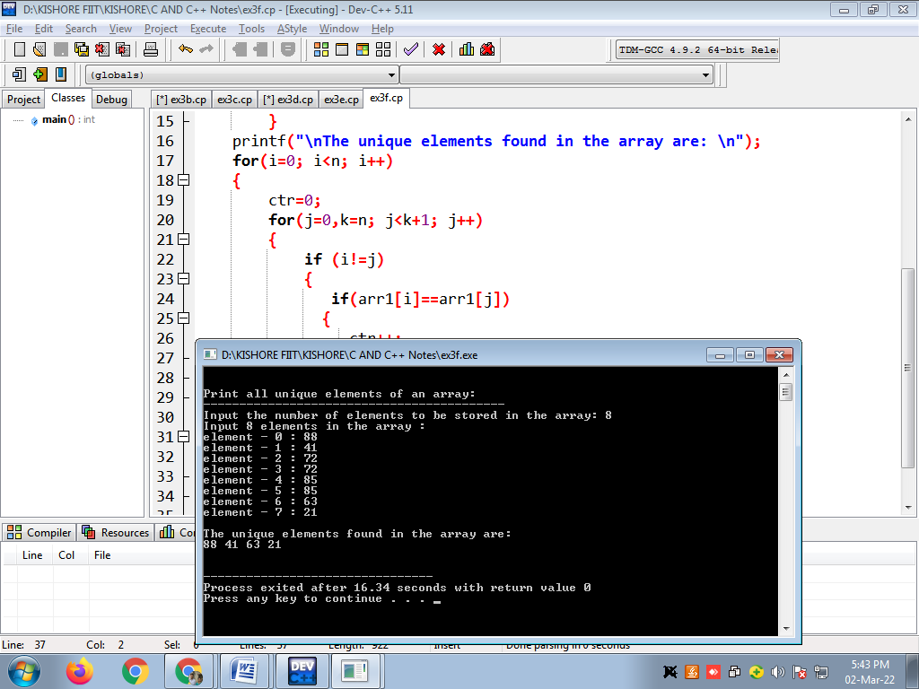

**7.Write a program in C to merge two arrays of same size sorted in decending order**

**#include <stdio.h>**

**int main()**

**{**

**int arr1[100], arr2[100], arr3[200];**

**int s1, s2, s3;**

**int i, j, k;**

**printf("\n\nMerge two arrays of same size sorted in decending order.\n");**

**printf("------------------------------------------------------------\n");**

**printf("Input the number of elements to be stored in the first array :");**

**scanf("%d",&s1);**

**printf("Input %d elements in the array :\n",s1);**

**for(i=0;i<s1;i++)**

**{**

**printf("element - %d : ",i);**

**scanf("%d",&arr1[i]);**

**}**

**printf("Input the number of elements to be stored in the second array :");**

**scanf("%d",&s2);**

**printf("Input %d elements in the array :\n",s2);**

**for(i=0;i<s2;i++)**

**{**

**printf("element - %d : ",i);**

**scanf("%d",&arr2[i]);**

**}**

**s3 = s1 + s2;**

**for(i=0;i<s1; i++)**

**{**

**arr3[i] = arr1[i];**

**}**

**for(j=0;j<s2; j++)**

**{**

**arr3[i] = arr2[j];**

**i++;**

**}**

**{**

**for(k=0;k<s3-1;k++)**

**{**

**if(arr3[k]<=arr3[k+1])**

**{**

**j=arr3[k+1];**

**arr3[k+1]=arr3[k];**

**arr3[k]=j;**

**}**

**}**

**}**

**printf("\nThe merged array in decending order is :\n");**

**for(i=0; i<s3; i++)**

**{**

**printf("%d ", arr3[i]);**

**}**

**printf("\n\n");**

**return 0;**

**}**

**Output:**

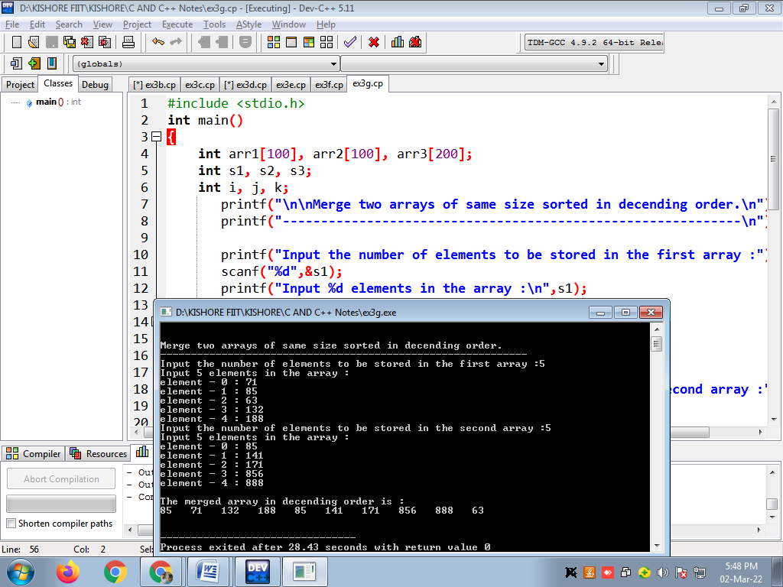

**8. Write a program in C to count the frequency of each element of an array.**

**#include <stdio.h>**

**int main()**

**{**

**int arr1[100], fr1[100];**

**int n, i, j, ctr;**

**printf("\n\nCount frequency of each element of an array:\n");**

**printf("------------------------------------------------\n");**

**printf("Input the number of elements to be stored in the array :");**

**scanf("%d",&n);**

**printf("Input %d elements in the array :\n",n);**

**for(i=0;i<n;i++)**

**{**

**printf("element - %d : ",i);**

**scanf("%d",&arr1[i]);**

**fr1[i] = -1;**

**}**

**for(i=0; i<n; i++)**

**{**

**ctr = 1;**

**for(j=i+1; j<n; j++)**

**{**

**if(arr1[i]==arr1[j])**

**{**

**ctr++;**

**fr1[j] = 0;**

**}**

**}**

**if(fr1[i]!=0)**

**{**

**fr1[i] = ctr;**

**}**

**}**

**printf("\nThe frequency of all elements of array : \n");**

**for(i=0; i<n; i++)**

**{**

**if(fr1[i]!=0)**

**{**

**printf("%d occurs %d times\n", arr1[i], fr1[i]);**

**}**

**}**

**return 0;**

**}**

**Output:**

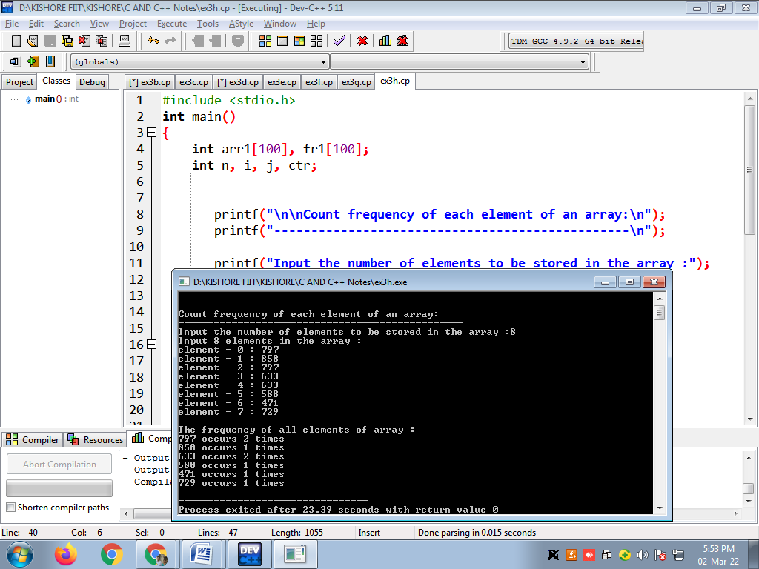

**9. Write a program in C to find the maximum and minimum element in an array.**

**#include <stdio.h>**

**int main()**

**{**

**int arr1[100];**

**int i, mx, mn, n;**

**printf("\n\nFind maximum and minimum element in an array :\n");**

**printf("--------------------------------------------------\n");**

**printf("Input the number of elements to be stored in the array :");**

**scanf("%d",&n);**

**printf("Input %d elements in the array :\n",n);**

**for(i=0;i<n;i++)**

**{**

**printf("element - %d : ",i);**

**scanf("%d",&arr1[i]);**

**}**

**mx = arr1[0];**

**mn = arr1[0];**

**for(i=1; i<n; i++)**

**{**

**if(arr1[i]>mx)**

**{**

**mx = arr1[i];**

**}**

**if(arr1[i]<mn)**

**{**

**mn = arr1[i];**

**}**

**}**

**printf("Maximum element is : %d\n", mx);**

**printf("Minimum element is : %d\n\n", mn);**

**return 0;**

**}**

**Output:**

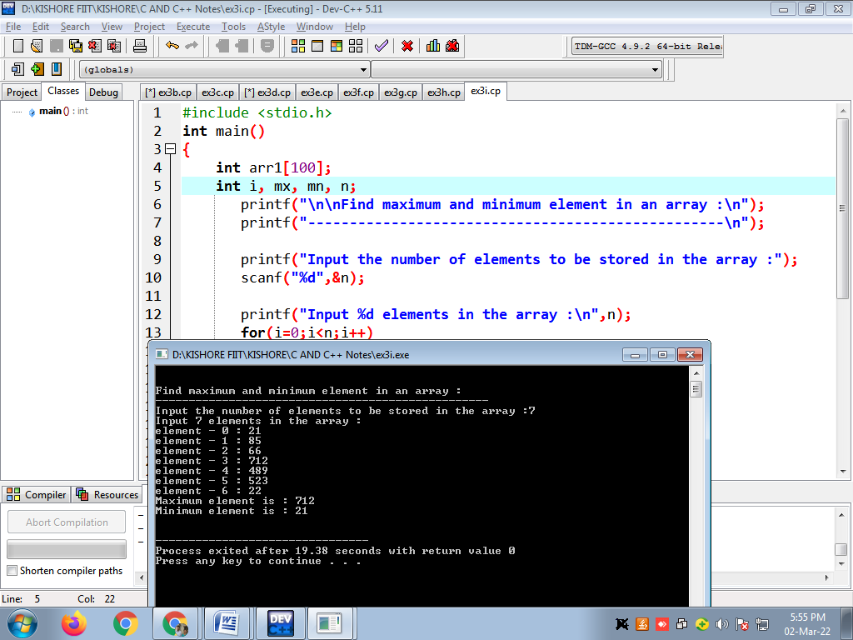

**10. Write a program in Cto separate odd and even integers in separate arrays**

**#include <stdio.h>**

**int main()**

**{**

**int arr1[10], arr2[10], arr3[10];**

**int i,j=0,k=0,n;**

**printf("\n\nSeparate odd and even integers in separate arrays:\n");**

**printf("------------------------------------------------------\n");**

**printf("Input the number of elements to be stored in the array :");**

**scanf("%d",&n);**

**printf("Input %d elements in the array :\n",n);**

**for(i=0;i<n;i++)**

**{**

**printf("element - %d : ",i);**

**scanf("%d",&arr1[i]);**

**}**

**for(i=0;i<n;i++)**

**{**

**if (arr1[i]%2 == 0)**

**{**

**arr2[j] = arr1[i];**

**j++;**

**}**

**else**

**{**

**arr3[k] = arr1[i];**

**k++;**

**}**

**}**

**printf("\nThe Even elements are : \n");**

**for(i=0;i<j;i++)**

**{**

**printf("%d ",arr2[i]);**

**}**

**printf("\nThe Odd elements are :\n");**

**for(i=0;i<k;i++)**

**{**

**printf("%d ", arr3[i]);**

**}**

**printf("\n\n");**

**return 0;**

**}**

**Output:**

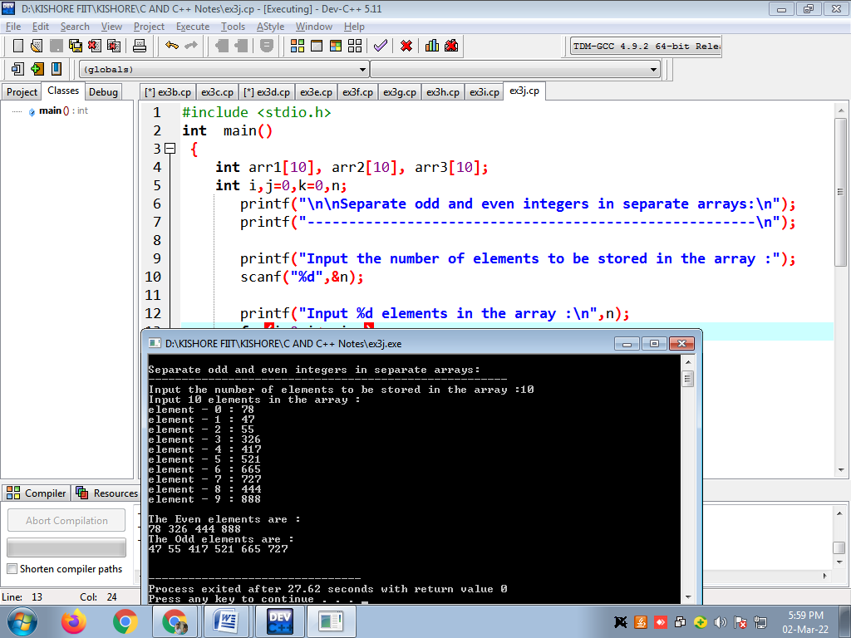

**11. Write a program in C to sort elements of array in ascending order**

**#include <stdio.h>**

**int main()**

**{**

**int arr1[100];**

**int n, i, j, tmp;**

**printf("\n\nsort elements of array in ascending order :\n ");**

**printf("----------------------------------------------\n");**

**printf("Input the size of array : ");**

**scanf("%d", &n);**

**printf("Input %d elements in the array :\n",n);**

**for(i=0;i<n;i++)**

**{**

**printf("element - %d : ",i);**

**scanf("%d",&arr1[i]);**

**}**

**for(i=0; i<n; i++)**

**{**

**for(j=i+1; j<n; j++)**

**{**

**if(arr1[j] <arr1[i])**

**{**

**tmp = arr1[i];**

**arr1[i] = arr1[j];**

**arr1[j] = tmp;**

**}**

**}**

**}**

**printf("\nElements of array in sorted ascending order:\n");**

**for(i=0; i<n; i++)**

**{**

**printf("%d ", arr1[i]);**

**}**

**printf("\n\n");**

**return 0;**

**}**

**Output:  
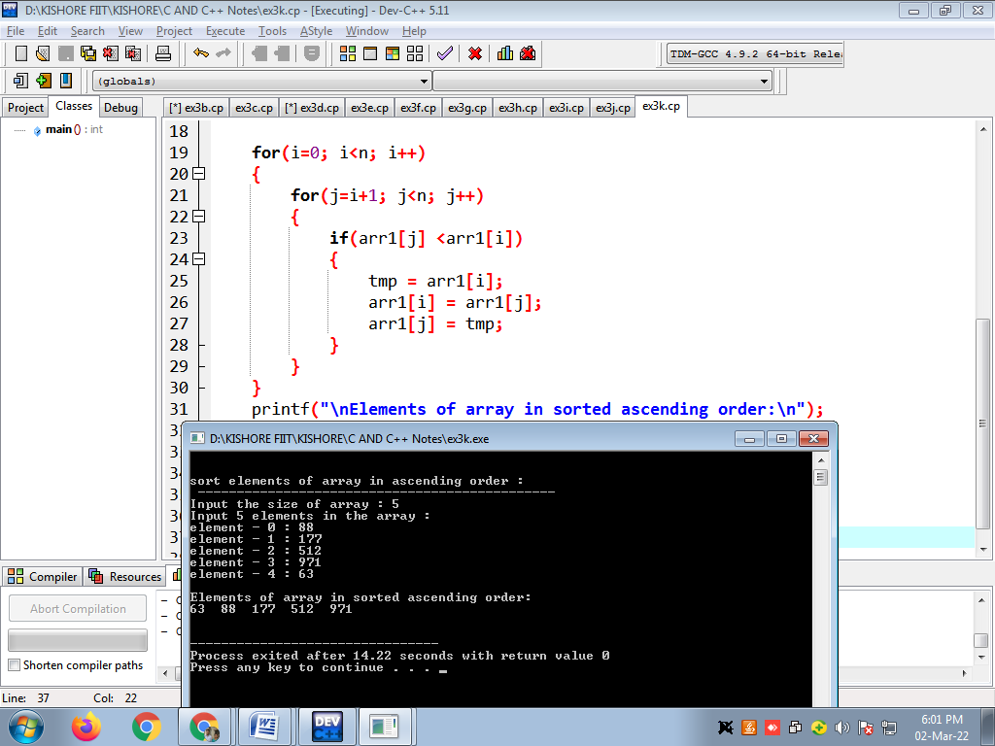**

**12. Write a program in C to sort elements of the array in descending order.**

#include <stdio.h>

int main()

{

int arr1[100];

int n, i, j, tmp;

printf("\n\nsort elements of array in descending order :\n");

printf("----------------------------------------------\n");

printf("Input the size of array : ");

scanf("%d", &n);

printf("Input %d elements in the array :\n",n);

for(i=0;i<n;i++)

{

printf("element - %d : ",i);

scanf("%d",&arr1[i]);

}

for(i=0; i<n; i++)

{

for(j=i+1; j<n; j++)

{

if(arr1[i] < arr1[j])

{

tmp = arr1[i];

arr1[i] = arr1[j];

arr1[j] = tmp;

}

}

}

printf("\nElements of array is sorted in descending order:\n");

for(i=0; i<n; i++)

{

printf("%d ", arr1[i]);

}

printf("\n\n");

return 0;

}

Output:

